Domain Model and Process Analysis
Team name
Project domain
Team members | Sahil Dalal, Jaritzy Hinojosa, Adan Villa, Remy Huynh
Submission date
Version | V2.0

Overview
These are instructions for portfolio items 3 and 4. Your deliverables are organized in three sections and each feeds into subsequent portfolio items. Two main diagrams have to be drawn in drawio (or some alternative diagramming software with the instructor’s approval).

 | Section | Deliverable | Used in
A | ERD and annotated domain model | ERD diagram + annotation worksheet | C4 container diagram (service boundaries). Data inventory (which service owns what personal data). Week 8 vibe-coding brief (data model description).
B | Context boundary summary | Context table; one row per bounded context | C4 diagram (containers correspond to bounded contexts). ADRs (justify the context boundary decisions).
C | BPMN process analysis | As-is swimlane + to-be swimlane + process rationale | API design (the to-be process defines what the API must support). low-fidelity prototype (user flows correspond to to-be process steps).

Alignment with your user story backlog.
Every entity in Section A should be referenced by at least one user story in Portfolio Item 2. Every step in Section C to-be process should implement at least one user story. Before submitting, run a quick check: can you trace each entity to a story, and each to-be process step to a story? If not, either the ERD is over-engineered or the backlog is incomplete.

Section A: ERD and Annotated Domain Model

A1: ERD diagram
Attach or embed your completed ERD below. Your ERD must be produced in draw.io or equivalent diagramming tool and the file need to be included in your project’s git repository.

ERD minimum requirements.
All core entities for your domain with primary keys and key attributes. All relationships with cardinality (1:1, 1:N, M:N) and mandatory/optional indicators. Foreign key references shown. No attributes that belong in a separate entity.

Once you have finalized your ERD on drawio, you can export as image and insert below (optional).

A2: Annotation worksheet
Complete one row per entity in your ERD. This worksheet is the core of the domain model, it shows service ownership, aggregate membership, bounded context assignment, and cross-boundary dependencies.

Annotation rules.
Every entity belongs to exactly one aggregate and one bounded context. The aggregate root is the only entity through which external code accesses the aggregate. Cross-boundary references show only the identifier exchanged (e.g. MemberId), never replicate full entity data across a boundary. If you find an entity that seems to belong to two contexts, it is a signal that your context boundary is in the wrong place.

Draw a box around entities that belong to a bounded context (color coding is recommended for readability but not required). Use dashed lines to show cross-boundary relationships. See the sports club sample project annotated ERD on D2L for a fully worked example.

Entity | Aggregate (mark root with ★) | Bounded context | This service is responsible for... | Cross-boundary ref to
User | User ★ | Identity & Access | User account identity, authentication, roles, and notification preferences | None – other contexts reference identity
StudentOrg | StudentOrg ★ | Organization | Org identity, org type, verification status, and authorized members | User.user_id → Identity (via OrgMembership, managed through StudentOrg root)
OrgMembership | StudentOrg (internal entity, not a root) | Organization | Links a verified user to a student org, accessed only through StudentOrg root | managed through StudentOrg aggregate root
Listing | Listing ★ | Listing | Free item post lifecycle, creation, approval, expiry, and status transitions | StudentOrg.org_id → Organization
Category | Listing (internal entity, not a root) | Listing | Classifies listings by type, accessed through the Listing root | None
Location | Listing (internal entity, not a root) | Listing | Campus building and room for a giveaway, accessed through the Listing root | None
SavedListing | SavedListing ★ | Saved | Student bookmark records | User.user_id → Identity, Listing.listing_id → Listing
Notification | Notification ★ | Notification | Delivery records, messages, channel, sent time, read state | User.user_id → Identity, Listing.listing_id → Listing
ModerationAction | ModerationAction ★ | Governance | Admin decisions on listing and the trail of who acted and why | Listing.listing_id → Listing, User.user_id → Identity

Section B: Context Boundary Summary
Complete one row per bounded context. The contexts here must correspond exactly to the boundaries marked on your ERD in Section A. The service owner column will later become a container in your C4 diagram.

Bounded context | Entities / aggregates within | Service owner | Cross-boundary references
Identity | User (AR) | Identity service | Referenced by all other contexts via User.user_id — does not reference outward
Organization | StudentOrg (AR), OrgMembership (internal) | Organization service | StudentOrg → User.user_id (Identity) via OrgMembership member list
Listing | Listing (AR), Category (internal), Location (internal) | Listing service | Listing → StudentOrg.org_id (Organization)
Saved | SavedListing (AR) | Engagement service | SavedListing → User.user_id (Identity), SavedListing → Listing.listing_id (Listing)
Notification | Notification (AR) | Notification service | Notification → User.user_id (Identity), Notification → Listing.listing_id (Listing)
Governance | ModerationAction (AR) | Governance service | ModerationAction → Listing.listing_id (Listing), ModerationAction → User.user_id (Identity)

Context boundary justifications
For each context boundary you drew, explain in two to four sentences: (a) which business capability the context represents, (b) why these entities belong together, and (c) what would happen if the boundary were drawn differently.

Context 1: ___Identity_________
The Identity context owns the single source of truth for who can use the system. All other contexts need to know if a user is a verified org, student, or admin - but no context should own that information itself. By separating out Identity from the rest of the application, we ensure that changes to authentication are isolated to only one context of our application.

Context 2: ____Organization______________
The Organization context owns the verification lifecycle of orgs and departments. While identity determines if a user account is legitimate, the Organization context determines if an org is legitimate through a separate approval process. Their separate states and administrators allow for this approval workflow to occur without involving the Identity context in such a process.

Context 3: ____Listing___________
The Listing context owns the data that is published by the organizations. The Category and Location contexts only exist to describe the listings so they do not have any meaning outside of that context. The lifecycle of a listing is owned by this context. Other contexts react to the listing but do not own or modify the listing data itself.

Context 4: ____Governance____________
The Saved context will track the bookmarks that students create for listings. This context is separate from the Notification context because saving a listing and being notified of a listing are two separate actions that can be performed by a student. A student can save and un-save a listing. A notification can only be read by the student. Hence, combining these two actions would result in a context that does not have a consistency rule governing the data within it.

Context 5: ____ Notification____________
The Notification context owns delivery of notifications to students. It is separated from Listing because the notification logic is separate from the listing logic. If in the future there was a change to the notification logic, only the Notification context would need to be changed.

Context 6: _____Governance____________
The Governance context owns the moderation of the platform - who gets to approve or reject listings and who gets to audit such decisions. This is separated from the Listing context as moderation belongs to a different entity with different data retention rules (admins only). When an admin approves a listing, the Listing context’s AR is called to update the listing status, again decoupling these two contexts.

Section C: BPMN Process Analysis

C1: Process selected
Identify the process you have chosen to model. It should be the most important repeating process in your system; the one that most directly motivates the system being built.

Process modelled | Posting a free-item system that clubs/professors/orgs and making location/item more discoverable to students
Primary actor | Student Org Rep (Poster) Secondary: Student, system admin
Why this process | This is the supply part loop of the system. Without it, there is no free items to discover, no data or notifications to track/send. Everything feeds off this process
Key pain points | - Announcements are scattered across various platform (e.g. snapchat, Instagram, TikTok, flyers)  - No verification: Students can’t tell what is real or fake  - Posts go stale: Flyers stay up even after items are gone  - Reach is limited to those who see a flyer or view a specific account  - No way to measure who saw or claimed items, tracking supply/demand

C2: As-is swimlane diagram
Attach or embed your as-is swimlane diagram below. The diagram must be produced in draw.io, Miro, or equivalent. Each task must be labelled with its value-added classification (VA, BVA, or NVA).
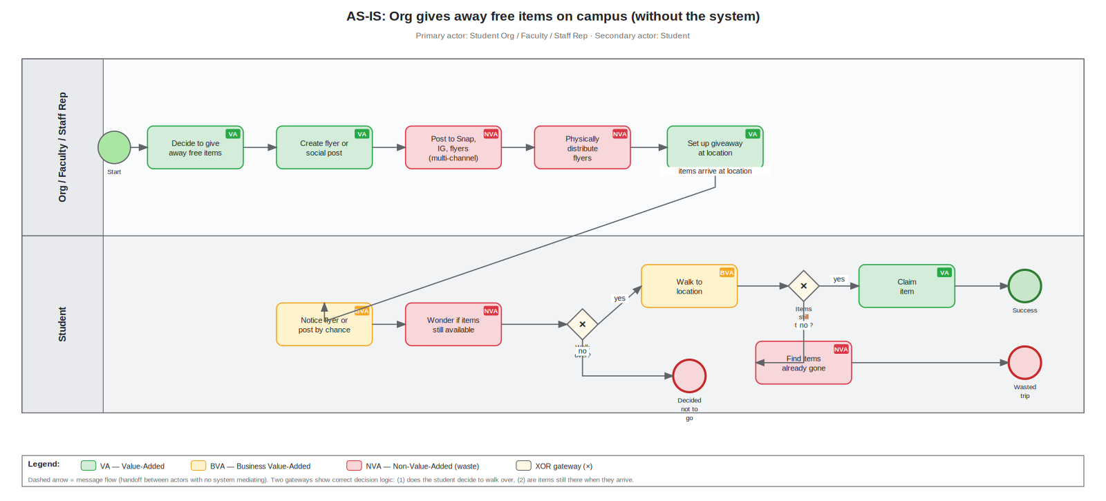

As-is activity inventory
Activity | Actor | VA / BVA / NVA | Reasoning
Decides to give away free items | Org Rep/Staff | VA | the poster choosing to give items away is the act that makes the whole process possible
Create flyer or social media post | Org Rep/Staff | VA | Producing the announcement is the creative work the poster wants to do, it directly communicates what is being given away
Post to multiple channels (Snap, IG, Flyers) | Org Rep/Staff | NVA | The same information is recreated and posted across three or four separate platforms. Duplicate effort with no added value, exists only because there is no single canonical channel
Physically hand out flyers on campus | Org Rep/Staff | NVA | Manual labor with extremely limited reach. Costs time and is invisible to anyone not walking past the right hallway at the right moment
Set up giveaway at location | Org Rep/Staff | VA | The actual giveaway event, the moment of value exchange between the poster and the student
Notice flyer or post by chance | Student | BVA | Discovery is a necessary step but it is almost entirely luck-based today. Students who do not follow the right accounts or walk past the right flyer never find out
Wonder if items are still there or available | Student | NVA | Pure waste caused entirely by the lack of real-time information. The student burns time and mental energy on something that should be a simple fact
Decide whether to walk over (gateway 1) | Student | NVA | The student has to make a risk-based decision with no reliable information, if they knew for certain items were still available they would just go
Walk to location | Student | BVA | Going to claim the item is necessary, but the uncertainty from the previous step means a significant portion of these trips will be wasted
Claim item (success path, gateway 2: yes) | Student | VA | The actual outcome both parties want, the student gets the free item and the poster achieves their goal of giving it away
Find items already gone (failure path, gateway 2: no) | Student | NVA | Pure waste, the student made the trip for nothing because there was no real-time availability information and no expiry notification

C3: To-be swimlane diagram
Attach or embed your to-be swimlane diagram. Each task must be labelled (H) human or (S) system. The process must include a 'System' lane. NVA activities from the as-is should not appear in the to-be unless explicitly justified.

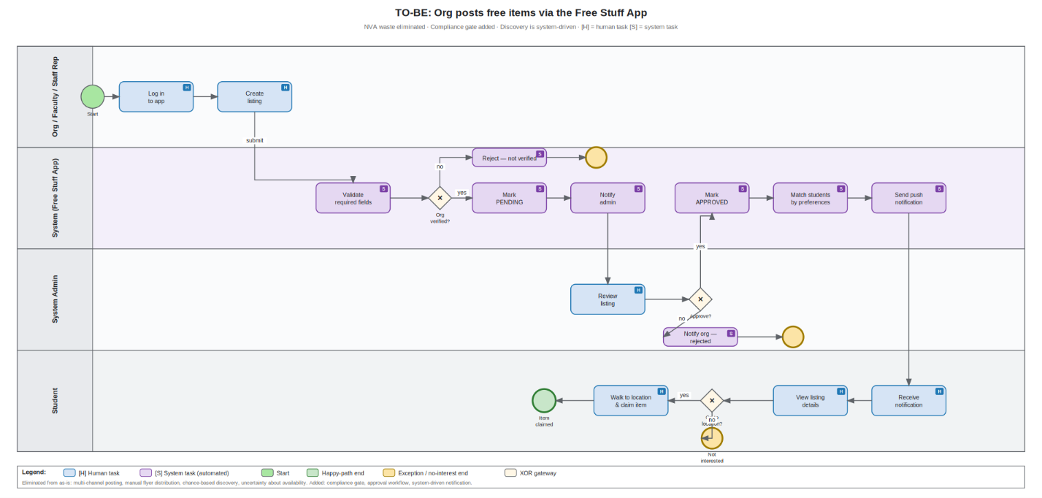

C4: Process rationale
For each significant change between as-is and to-be, document what changed, why, and which user story it implements.

What changed | Why (design rationale) | User story(ies) implemented
Fragmented multi-channel posting (Snap, IG, flyers) replaced with a single in-app listing form) | Eliminates duplicate effort for orgs, faculty, and staff. Creates one canonical place students check. Without this consolidation, notifications and analytics are impossible | US-02, US-07
Manual flyer distribution eliminated entirely replaced by system-driven push notifications | The biggest NVA-to-system conversion in the process. The poster no longer walks the building taping up flyers. The system reaches every eligible student instantly | US-05, US-09
Admin approval added as a mandatory step before any listing goes public | Adds one BVA step the as-is process lacked, but it is the only defense against fake or policy-violating posts reaching students. Trust in the platform is a prerequisite | US-04, US-06
Org verification gate added unverified accounts cannot submit listings | Prevents impersonation. Only accounts with VERIFIED status can create listings. Unverified accounts are rejected at submission before anything reaches the admin | US-04
Listings auto-expire via end_time attribute, no more stale posts | Directly eliminates the "find items already gone" NVA outcome from the as-is. A listing that has passed its end_time is automatically hidden from the feed | US-01, US-07
Student notification preference matching added before push is sent | Students only receive alerts about listings that match their saved preferences and location filters. Prevents notification overload | US-05, US-09
Student can now decide to go based on full listing details | The "wonder if items still available" NVA step is eliminated. Students see exact location, description, and time remaining before deciding to go or not | US-07

Assessment Rubric
Portfolio items 3 and 4 have 12 (out of 85) points of the project.

Criterion | Wt | Description | Good | Satisfactory | Pass / Rework
ERD completeness and accuracy | 20% | All core entities present with appropriate attributes. Relationships correctly specified with cardinality. No missing FK relationships. | All entities, attributes, and relationships (including cardinalities) correct. | All core entities present. Minor attribute or cardinality gaps. | Key entities missing or incorrectly related. Cardinality absent or wrong.
Domain model annotation | 30% | Every entity assigned to an aggregate with named root. Context boundaries clearly drawn. Service ownership labelled for each context. Cross-boundary references explicitly identified. | All aggregates identified with correct roots. Context boundaries reflect business capabilities, not technical convenience. Every cross-boundary reference named and justified. | Most aggregates correctly identified. Context boundaries present but some reflect technical rather than domain logic. Some cross-boundary references identified. | Aggregates absent or incorrectly formed. Context boundaries missing or arbitrary. Cross-boundary references not identified.
Context boundary justification | 10% | Each context boundary is justified in the summary table, explaining which entities belong together and why, and what the cost of the boundary is. | All boundaries justified with domain reasoning. At least one boundary challenged and reconsidered with documented rationale. | Most boundaries justified. Justifications reference domain behavior, not just entity groupings. | Boundaries not justified or justified with only 'these entities are related' without domain reasoning.
BPMN as-is accuracy | 15% | As-is swimlane correctly captures the current process with the right actors in the right lanes. Decision points, exceptions, and handoffs are shown. Value-added analysis is complete. | Full as-is process captured including exceptions. Value-added analysis correctly classifies all activities. Pain points are explicitly labelled. | Core as-is process captured. At least one exception shown. Value-added analysis present with minor misclassification. | As-is process incomplete or inaccurate. Actors in wrong lanes. Value-added analysis absent.
BPMN to-be and process rationale | 25% | To-be swimlane shows the future system with system tasks clearly distinguished from human tasks. Eliminated and automated steps are explicitly noted. The process rationale explains what changed and why. | To-be reflects genuine process redesign, not just digitization. Eliminated steps are named. Rationale connects process changes to user story backlog. | To-be shows the future process with some automation. System tasks distinguished from human tasks. Brief rationale present. | To-be is identical to as-is with a database added. No process redesign. Rationale absent or generic.

Connection to future weeks.
The bounded contexts in Section B become the containers in your C4 diagram. Before Week 5, review your context boundary summary and confirm that each context is coherent enough to be a deployable service. If two contexts always change together, they should probably be one. If one context is doing too many unrelated things, it should probably be split.

Revision Log
Version | Date | Revised by | What changed and why
v1.0 | Initial submission

